BIOS Flash procedure in Window(XP & Vista)

Step 1) unzip the zip file which is provide by LG.
-. Create folder “aaa”(the folder name must be “aaa”) to C:\ root.
-. Unzip the zip file to “aaa” folder.
-. If folder name is like “New Folder”, the flash program doesn’t run well.

Step 2) open the “aaa” folder

Step 3) execute “AFUWIN.exe”
-. In case OS is Vista, run “AFUWIN.exe” as Administrator mode,
(Refer to below picture)
-. In case OS is XP, run “AFUWIN.exe”
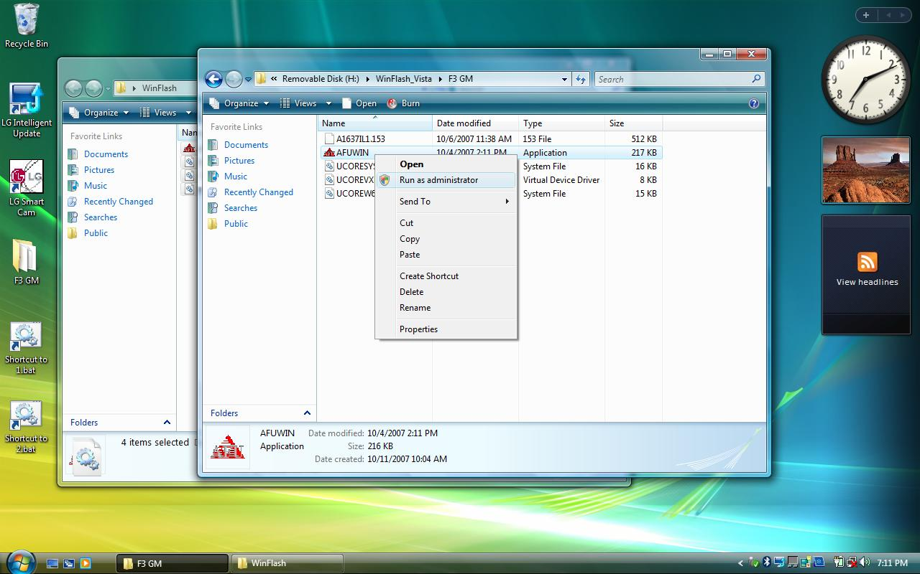

Step 4) Click “OK” button in below picture.
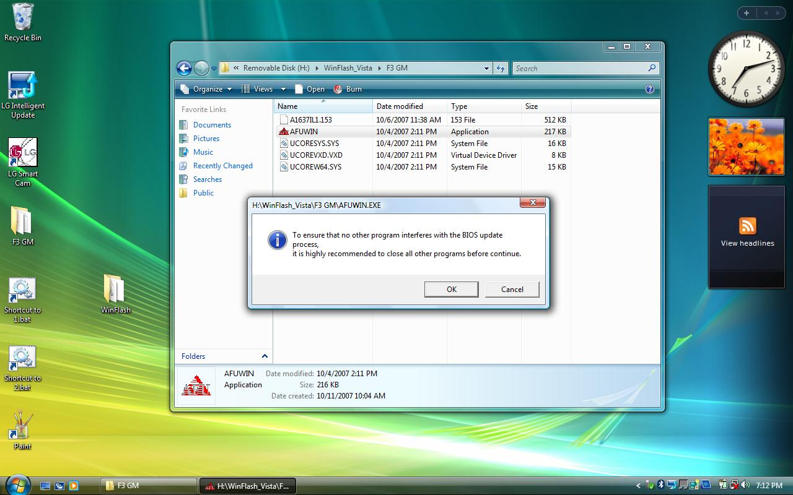

Step 5) Click “Open” button in below picture.
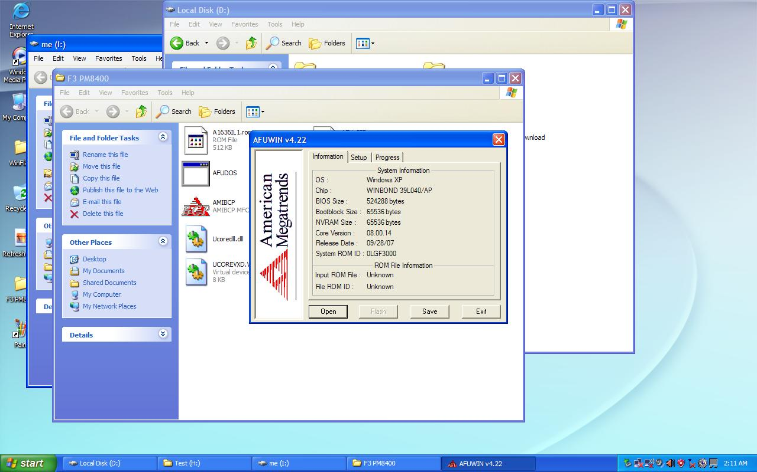

Step 6) find bios rom file in the “aaa” folder, Click “Open” button in below picture.
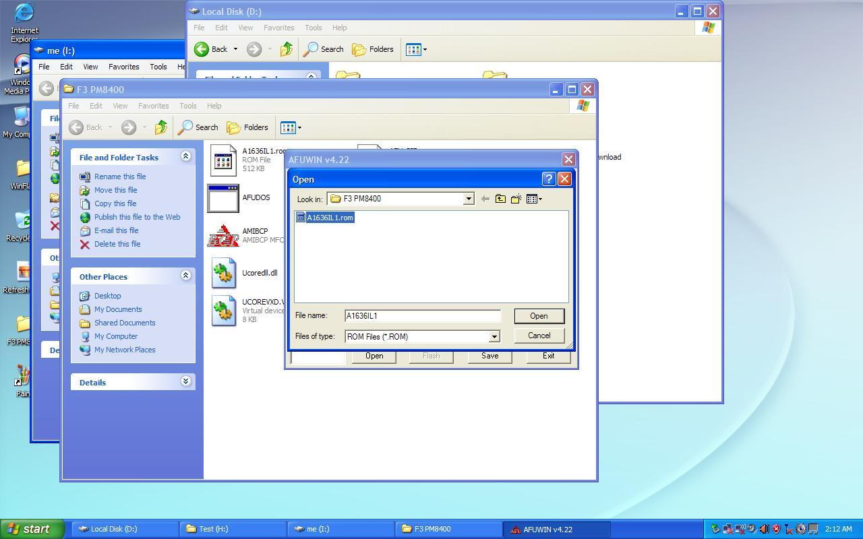

Step 7) check “main bios image”, “Boot Block”, “EC Block”,
Click “Flash” button in below picture.
(Don’t check “NVRAM” at block option)
Wait during flash bios rom….
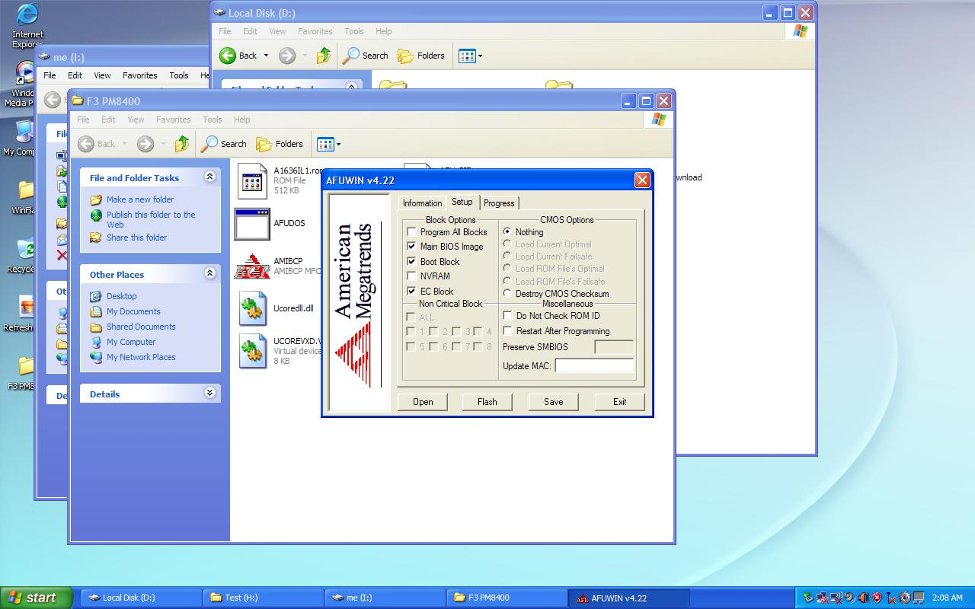

Step 8) Click “Exit” button in below picture.
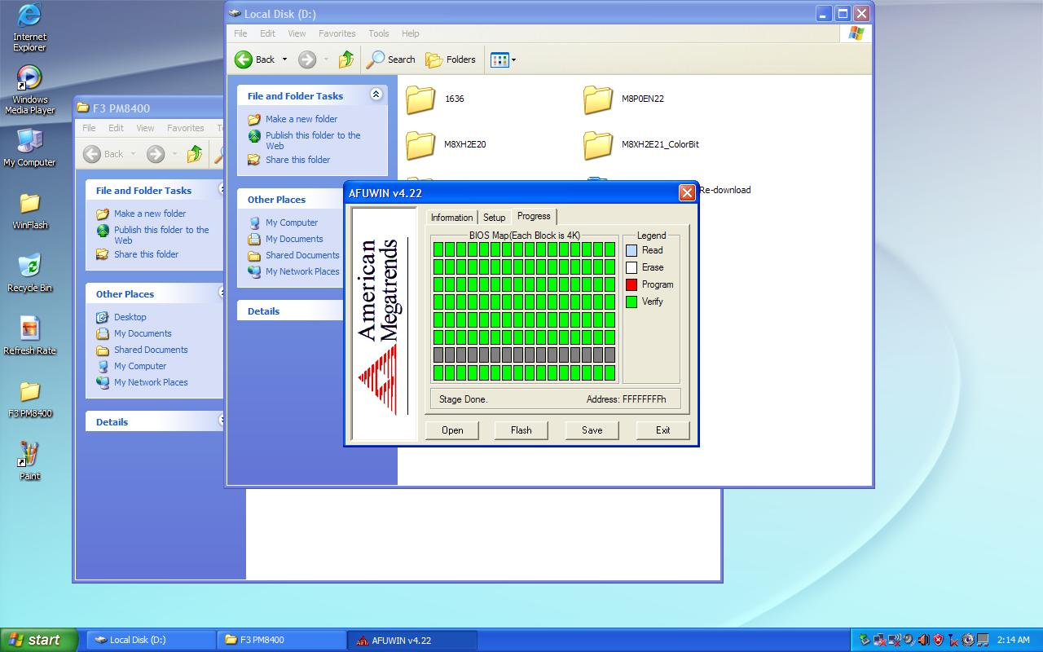

Step 9) Finally Reboot the System.

Step 10) during restarting the system
Press F2 to enter the BIOS setup menu,
Then, press F9 to set the “Load Setup Defaults”,
Finally, press F10 to save configuration change.

Reference picture

* Oversee SKU Logo Picture.


* Korean SKU Logo Picture.


